Training Report

On

Predictive Analysis of Student Academic

Performance Using Linear Regression

Submitted in partial fulfillment of the requirements For the award of the degree of
BACHELOR OF TECHNOLOGY
in
CSE AIML
Submitted by
Nitish, Aryan
Roll No:28240529,
28240533

Batch (2024-2028)



Panipat Institute of Engineering & Technology, (Affiliated to Kurukshetra University Kurukshetra, India) Samalkha , Panipat
(Session:2024-2028)
CANDIDATE’S DECLARATION

I hereby declare that the work presented in this training report entitled “Predictive Analysis of Student Academic Performance Using Linear Regression ”, submitted in partial fulfilment of the requirement for the award of the degree of Bachelor of Technology in CSE AIML, submitted to Panipat Institute of Engineering & Technology, Kurukshetra University, Kurukshetra, India is an authentic record of my own work carried out during the period from 10th July to 25th Aug under the guidance of Miss Richa Choudhary .

Date: | Nitish, Aryan
Place: Panipat Institute of Engineering Technology | 28240529, 28240533

Certificate

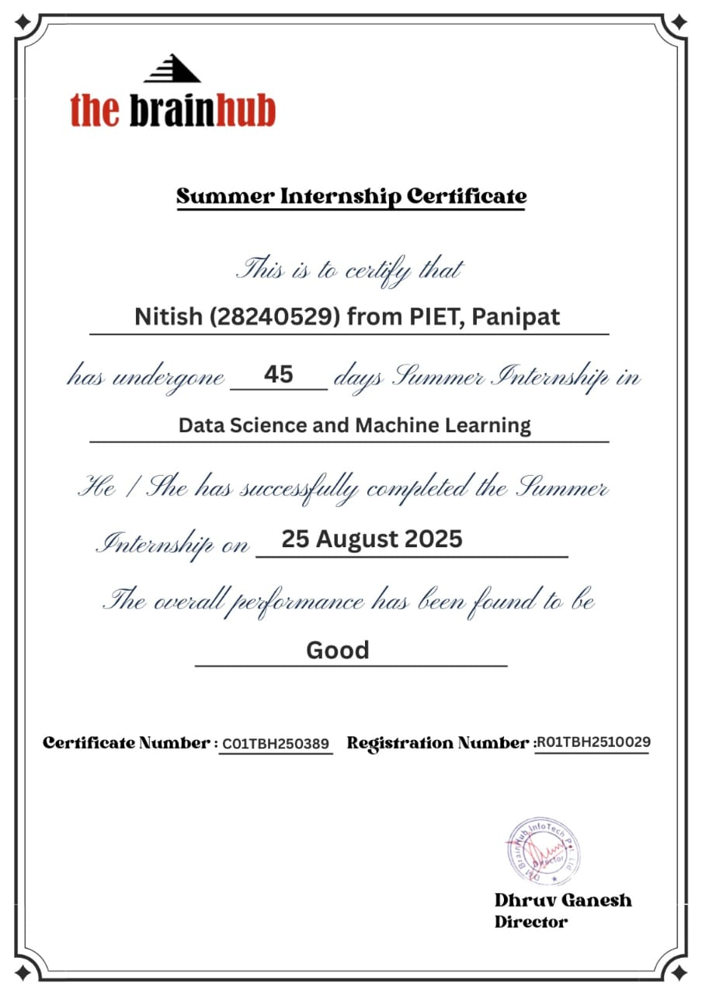
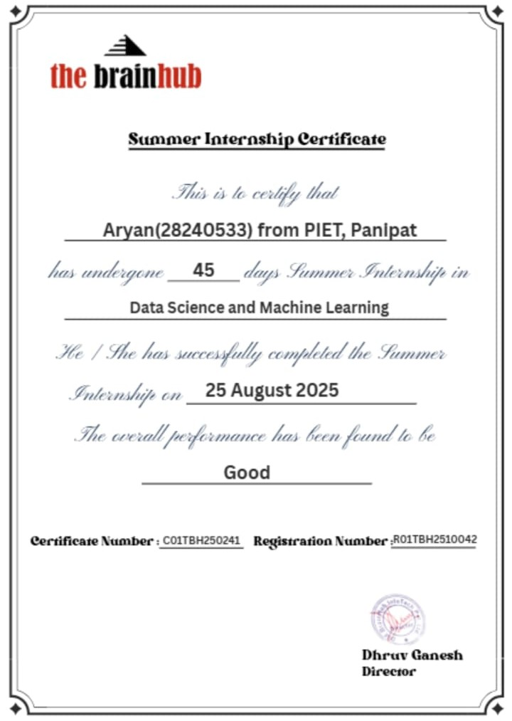

ABSTRACT

In an increasingly data-driven world, the education sector is turning to data science and machine learning to gain deeper insights into student learning processes. The ability to predict student academic performance is a key area of research in Educational Data Mining (EDM). Early prediction of student outcomes can help educators identify at-risk students, enabling timely interventions and the development of personalized learning paths. This, in turn, can significantly improve student retention, success rates, and overall educational quality.
This project focuses on this problem by developing a foundational predictive model. The primary objective is to build and evaluate a Simple Linear Regression model to predict a student's academic score based on a single, highly correlated feature: the number of hours studied.

Contents:

 | CONTENTS
Candidate's Declaration | 2
Certificate | 3
Abstract | 4
Contents | 5
Index | 6
List of Figures | 8

Index:

Chapter No. | Description | Page No.
Chapter 1: | INTRODUCTION | 8
 | 1.1 Project Background | 8
 | 1.2 The Rise of Educational Data Mining (EDM) | 9
 | 1.3 Problem Statement | 10
 | 1.4 Internship and Project Objectives | 11
 | 1.5 Significance and Potential Applications | 12
 | 1.6 Report Structure | 13
Chapter 2: | Company Profile – The Brain Hub | 14
 | 2.1 Overview | 14
 | 2.2 Mission and Vision | 15
 | 2.3 Core Values | 16
 | 2.4 Services and Offerings | 17
 | 2.5 Internship Experience | 18
Chapter 3: | Literature Review | 19
 | 3.1 Overview of Predictive Analysis in Education | 19
 | 3.2 Common Machine Learning Techniques in EDM | 20
 | 3.2.1 Regression Models | 21
 | 3.2.2 Classification Models | 22
 | 3.2.3 Clustering Models | 23
 | 3.3 Key Features Used in Performance Prediction | 24
 | 3.4 The Role of Linear Regression as a Baseline | 25
 | 3.5 Research Gap and Project Niche | 26
Chapter 4: | Methodology and System Design | 27
 | 4.1 Project Workflow | 27
 | 4.2 Tools and Technologies | 28
 | 4.2.1 Python 3.x | 28
 | 4.2.2 Pandas | 29
 | 4.2.3 Scikit-learn | 29
 | 4.2.4 Matplotlib | 30
 | 4.3 Dataset Description | 31
 | 4.4 Data Preprocessing | 32
 | 4.4.1 Feature-Target Separation | 33
 | 4.4.2 Training and Testing Split | 34
 | 4.5 Model In-Depth: Linear Regression | 35
 | 4.5.1 The Theoretical Concept | 36
 | 4.5.2 The Mathematical Model | 37
 | 4.5.3 Ordinary Least Squares (OLS) | 38
 | 4.5.4 Assumptions of Linear Regression | 39
Chapter 5: | Implementation and Code Analysis | 40
 | 5.1 Environment Setup | 40
 | 5.2 Step-by-Step Code Implementation | 41
 | 5.2.1 Step 1: Importing Libraries | 42
 | 5.2.2 Step 2: Dataset Creation | 43
 | 5.2.3 Step 3: Data Preparation and Splitting | 44
 | 5.2.4 Step 4: Model Training | 45
 | 5.2.5 Step 5: Making Predictions | 46
 | 5.2.6 Step 6: Visualization | 47
Chapter 6: | Results and Evaluation | 48
 | 6.1 Model Output | 48
 | 6.2 Evaluation Metrics | 49
 | 6.2.1 Mean Absolute Error (MAE) | 50
 | 6.2.2 Mean Squared Error (MSE) | 51
 | 6.2.3 Root Mean Squared Error (RMSE) | 52
 | 6.2.4 R-squared (Coefficient of Determination) | 53
 | 6.3 Analysis of Project Results | 54
 | 6.4 Analysis of Visualization | 55
Chapter 7: | Learning Outcomes and Discussion | 56
 | 7.1 Key Learning Outcomes | 56
 | 7.2 Interpretation of Findings | 57
 | 7.3 Limitations of the Project | 58
 | 7.4 Challenges Faced and Solutions | 59
Chapter 8: | Conclusion and Future Work | 60
 | 8.1 Conclusion | 60
 | 8.2 Future Work | 61
References |  | 62
Annexures |  | 63
 | Annexure 1: Complete Python Code | 64
 | Annexure 2: Output Screenshots | 65

List of Figures

Figure No. | Description | Page No.
Figure 1: | Project Workflow Diagram | 28
Figure 2: | Linear Regression: Line of Best Fit | 36
Figure 3: | OLS: Minimizing Residuals | 38
Figure 4: | Code: Importing Libraries | 42
Figure 5: | Code: Creating the Pandas DataFrame | 43
Figure 6: | Code: Splitting the Data | 44
Figure 7: | Code: Training the Linear Regression Model | 45
Figure 8: | Code: Making Predictions on Test Data | 46
Figure 9: | Code: Predicting for a New Value (9.25 Hours) | 47
Figure 10: | Code: Visualizing the Results with Matplotlib | 48
Figure 11: | Output: Actual vs. Predicted Values and MAE | 50
Figure 12: | Output: Prediction for 9.25 Hours | 51
Figure 13: | Output: Hours vs. Marks (Linear Regression) Plot | 52

Chapter 1: Introduction

1.1. Project Background
The field of education is undergoing a profound transformation. For centuries, the model of education has been largely static, relying on a one-size-fits-all curriculum delivered to a group of students. However, the advent of the digital age and the exponential growth of data have unlocked new possibilities. We now have the ability to collect and analyze vast amounts of data related to the learning process. This data, often referred to as "Educational Data," includes everything from test scores and homework grades to attendance records, time spent on e-learning platforms, and even social interactions.
This data explosion has given rise to a new and exciting field: Educational Data Mining (EDM). EDM applies data science, machine learning, and statistical methods to this educational data to uncover hidden patterns, understand student behavior, and ultimately, to improve educational outcomes.
One of the most critical applications of EDM is the ability to move from reactive to predictive education. Instead of waiting for a student to fail a course, predictive models can identify which students are at high risk of failing before it happens, allowing for timely and targeted support. This project, "Predictive Analysis of Student Academic Performance," is an entry into this transformative field. It seeks to explore the fundamental principles of predictive modeling by tackling a simple, yet foundational, question: "Can we predict a student's academic score based on their study habits?"

1.2. The Rise of Educational Data Mining (EDM)
Educational Data Mining (EDM) is an interdisciplinary field that sits at the intersection of computer science, statistics, and education. It is concerned with developing methods for exploring the unique types of data that come from educational settings and using those methods to better understand students and the settings which they learn in.
The primary goals of EDM are:
- Predicting Student Outcomes: Forecasting future performance, such as grades, test scores, or even graduation rates. This allows for proactive interventions.
- Providing Feedback and Personalization: Developing models that can power adaptive learning systems, which adjust the curriculum and difficulty in real-time based on a student's performance.
- Discovering Models of Learning: Understanding the underlying cognitive and behavioral processes of learning. For example, how does collaboration affect learning? What study patterns lead to long-term retention?
- Improving Educational Support: Helping instructors and administrators understand which teaching strategies are most effective, how to optimize a curriculum, or how to allocate resources more efficiently.
This project directly addresses the first and most common goal of EDM: predicting student outcomes. While real-world models are highly complex, they are all built upon the same foundational techniques, such as the Linear Regression model explored in this report. By understanding how to model the relationship between two variables—in this case, Hours Studied and Marks Scored—we build the fundamental knowledge required to tackle more complex, multi-variable problems in the future.

1.3. Problem Statement
The core problem this project addresses is the need for a simple, interpretable, and computationally inexpensive model to predict student performance.
In many educational contexts, especially at the institutional level, there is a strong desire to identify students who are at risk of poor academic performance. However, implementing complex deep learning or ensemble models can be computationally expensive and time-consuming. Furthermore, these complex models often suffer from a "black box" problem, where they can make accurate predictions but cannot explain why a particular prediction was made. This lack of interpretability is a significant barrier in education, where educators need to understand the reason for a student's risk in order to design an effective intervention.
Therefore, this project seeks to answer the following:
"To what extent can a student's academic score be accurately predicted using a simple, interpretable Linear Regression model based on the number of hours they study?"
This project intentionally simplifies the problem to one input variable (Hours) to establish a clear baseline and demonstrate the end-to-end machine learning workflow.
1.4. Internship and Project Objectives
This project was undertaken as part of the summer internship at The Brain Hub, a company specializing in data science and AI education. The primary goals of the internship were to bridge the gap between academic theory and practical, real-world application.
The specific objectives for this project were as follows:
- To gain practical knowledge of the Machine Learning workflow: This includes data collection, data preprocessing, model selection, model training, and model evaluation.
- To master core Python data science libraries:
  - Pandas: For data creation, manipulation, and preprocessing.
  - Scikit-learn: For implementing the machine learning model (Linear Regression), splitting data (train_test_split), and evaluating performance (mean_absolute_error).
  - Matplotlib: For data visualization, specifically plotting the dataset and the resulting regression line.
- To deeply understand and implement Linear Regression: Move beyond a purely theoretical understanding and practically apply one of the most fundamental algorithms in supervised learning.
- To learn model evaluation techniques: Understand how to measure the performance of a regression model using metrics like Mean Absolute Error (MAE) and interpret what that metric signifies.
- To develop problem-solving and analytical skills: Troubleshoot code, analyze data, interpret model results, and draw meaningful conclusions from the project.
1.5. Significance and Potential Applications
While this project uses a small, synthetic dataset, the model and workflow serve as a "proof of concept" for systems with significant real-world impact. The significance of this work lies in its potential to be scaled and applied in several ways:
- For Students: A model like this could be integrated into a student portal, allowing them to input their study schedule and receive a data-backed estimate of their likely performance. This could motivate students to manage their time more effectively.
- For Educators: Teachers and professors could use a more advanced version of this model (with more features) to identify students who are showing patterns of high risk early in the semester, allowing them to offer extra help or resources.
- For Institutions: University administrators could use aggregated data from these models to identify which courses have high failure rates and correlate that with student study patterns. This could lead to data-driven improvements in curriculum design, such as adding more support or prerequisites for difficult courses.
- For Adaptive Learning Systems: This simple model is the first step toward building sophisticated adaptive learning platforms. These platforms can adjust the content, pace, and difficulty of lessons in real-time, personalized to each student's learning patterns.
In essence, this project, though simple, is a fundamental building block for the data-driven future of education

Chapter 2: Company Profile - The Brain Hub

2.1. Overview
The internship was completed at The Brain Hub, an innovative company focused on technology, education, and professional skill development. Its philosophy is built on project-based learning in fields like Data Science, AI, and software development, bridging the gap between academia and industry. The Brain Hub provides a platform for students to gain real-world experience and build a strong portfolio. This internship was part of their "Data Science and Machine Learning" cohort.

2.2. Mission and Vision
Mission Statement "To democratize technology education by providing accessible, practical, and industry-relevant training. We aim to empower individuals with the skills and confidence to solve real-world problems and build successful careers in technology."
Vision Statement "To be a global leader in technology skill development, recognized for our innovative teaching methods, world-class curriculum, and our commitment to fostering a new generation of data-literate professionals and AI pioneers."
2.3. Core Values
The company's culture and training are guided by these core values:
- Practicality: Emphasizing hands-on application over pure theory.
- Continuous Learning: Keeping curriculum current with industry demands.
- Mentorship: Providing students with access to industry experts for guidance.
- Collaboration: Fostering a team-based environment that mimics the modern workplace.
- Accessibility: Offering diverse and flexible learning formats.
2.4. Services and Offerings
The Brain Hub provides a diverse portfolio of services:
- Intensive Bootcamps: Full-time, job-ready programs in Data Science, Web Development, and Cybersecurity.
- Part-Time Professional Courses: Evening/weekend courses for professionals upskilling in ML, Cloud Computing, etc.
- Internship Programs: Project-based mentorship programs, like this one, to build a portfolio.
- Corporate Training: Customized training solutions for companies to upskill their workforce.
- Free Workshops and Resources: Contributions to the tech community via free tutorials and workshops.
2.5. Internship Experience
My 45-day summer internship on the "Data Science and Machine Learning" track was a structured, intensive experience.
- Week 1-2: Foundations: Review of Python and the core data science stack (NumPy, Pandas, Matplotlib).
- Week 3: Machine Learning Theory: Introduction to supervised vs. unsupervised learning, key algorithms, and the bias-variance trade-off.
- Week 4-6: Project Work: Assigned the "Predictive Analysis" project. I was responsible for the complete workflow, from problem definition and coding to model analysis and final presentation, all under the guidance of a mentor.
The experience provided a clear, practical line of sight from a business problem to a functional, data-driven solution

Chapter 3: Literature Review

3.1 Overview of previous studies on Iris Flower Classification.
The Iris flower dataset has been extensively studied since its introduction by Ronald A. Fisher in 1936. It has become a foundational dataset in the fields of statistics, pattern recognition, and machine learning. This section provides an overview of notable studies and methodologies that have utilized the Iris dataset for classification tasks.

1. Fisher's Linear Discriminant Analysis (1936)
- Study: Fisher, R. A. (1936). "The use of multiple measurements in taxonomic problems."
- Contribution: Fisher introduced the dataset in his seminal paper and used it to develop Linear Discriminant Analysis (LDA), a method to find the linear combination of features that best separates the classes. Fisher's work demonstrated the effectiveness of LDA in classifying iris species based on the provided features.

2. Support Vector Machines (SVM)
- Study: Cortes, C., & Vapnik, V. (1995). "Support-vector networks."
- Contribution: This study introduced the concept of Support Vector Machines, a powerful classification algorithm. The Iris dataset was used to illustrate the ability of SVMs to handle linear and non-linear classification problems. SVMs became a popular choice for classification tasks due to their robustness and accuracy.

3. Decision Trees and Random Forests
- Study: Breiman, L. (2001). "Random forests."
- Contribution: Breiman's work on Random Forests, an ensemble learning method, showcased the improved accuracy and stability of classification results compared to individual decision trees. The Iris dataset was employed to demonstrate the effectiveness of Random Forests in handling small to medium-sized datasets with complex feature interactions.

4. k-Nearest Neighbors (k-NN)
- Study: Cover, T., & Hart, P. (1967). "Nearest neighbor pattern classification."
- Contribution: This study introduced the k-NN algorithm, a simple yet effective non-parametric method for classification. The Iris dataset has frequently been used to illustrate the principles of k-NN, where classification is based on the majority vote of the nearest neighbors.

5. Neural Networks
- Study: Rumelhart, D. E., Hinton, G. E., & Williams, R. J. (1986). "Learning representations by back-propagating errors."
- Contribution: The development of backpropagation for training neural networks marked a significant advancement in machine learning. The Iris dataset was used to demonstrate the ability of neural networks to learn complex decision boundaries through iterative training.

6. Principal Component Analysis (PCA)
- Study: Jolliffe, I. T. (1986). "Principal component analysis."
- Contribution: PCA is a dimensionality reduction technique that transforms data into a set of orthogonal components. The Iris dataset was used to show how PCA can reduce the number of features while preserving the variance, aiding in visualizing high-dimensional data and improving the performance of classification algorithms.

7. K-Means Clustering
- Study: MacQueen, J. (1967). "Some methods for classification and analysis of multivariate observations."
- Contribution: K-means clustering is an unsupervised learning algorithm used to partition data into clusters. Although primarily used for clustering, K-means has been applied to the Iris dataset to demonstrate how it can identify natural groupings within the data.

8. Modern Deep Learning Techniques
- Study: LeCun, Y., Bengio, Y., & Hinton, G. (2015). "Deep learning."
- Contribution: The advent of deep learning brought new approaches to classification problems. Convolutional Neural Networks (CNNs) and other deep learning architectures have been applied to the Iris dataset to illustrate their capabilities in learning from raw data with minimal preprocessing.

Key Insights from Previous Studies
Effectiveness of Linear Models: Fisher's initial use of LDA demonstrated that linear models could effectively separate the iris species based on the given features. This laid the foundation for many subsequent linear classification techniques.
Non-linear Classification: Techniques like SVMs and neural networks have shown that non-linear classifiers can achieve high accuracy by capturing more complex relationships between features.
Ensemble Methods: Random Forests and other ensemble methods have highlighted the importance of combining multiple models to improve classification performance and robustness.
Dimensionality Reduction: PCA and similar techniques have proven useful for visualizing high-dimensional data and enhancing the performance of machine learning models by reducing feature space.
Simplicity and Interpretability: Algorithms like k-NN and Decision Trees remain popular due to their simplicity and interpretability, making them accessible for educational purposes and practical applications.

3.2 Discussion on different Machine Learning Algorithms used in Flower Classification.
Classifying iris flowers using machine learning involves applying various algorithms to recognize patterns in the dataset and accurately predict the species. Here’s an in-depth discussion on several commonly used machine learning algorithms for flower classification:

1. k-Nearest Neighbors (k-NN)
Principle:
  - k-NN is a simple, instance-based learning algorithm that classifies a sample based on the majority vote of its k nearest neighbors in the feature space.
Strengths:
  - Easy to implement and understand.
  - Effective for small datasets.
  - No assumptions about the data distribution.
Weaknesses:
  - Computationally expensive for large datasets due to the need to calculate the distance of each test sample to all training samples.
  - Sensitive to the choice of k and the distance metric.
  - Poor performance with high-dimensional data due to the curse of dimensionality.
Use Case in Iris Dataset:
  - k-NN is often used as a baseline classifier for the Iris dataset. By adjusting the value of k, one can balance between bias and variance.

2. Decision Tree
Principle:
  - Decision Trees use a tree-like model of decisions and their possible consequences. They split the dataset into subsets based on the value of input features.
Strengths:
  - Easy to interpret and visualize.
  - Handles both numerical and categorical data.
  - Requires little data preprocessing.
Weaknesses:
  - Prone to overfitting, especially with complex trees.
  - Sensitive to noisy data.
  - Can create biased trees if some classes dominate.
Use Case in Iris Dataset:
  - Decision Trees can easily model the Iris dataset, and the resulting tree can be visualized to understand the decision-making process.

3. Random Forest
Principle:
  - Random Forests are an ensemble learning method that builds multiple decision trees and merges them to get a more accurate and stable prediction.
Strengths:
  - Reduces overfitting by averaging multiple trees.
  - Handles large datasets with higher dimensionality.
  - Robust to noise and outliers.
Weaknesses:
  - Less interpretable than a single decision tree.
  - Computationally intensive due to the large number of trees.
Use Case in Iris Dataset:
  - Random Forests are highly effective for the Iris dataset, often achieving high accuracy by leveraging the strength of multiple decision trees.

4. Support Vector Machine (SVM)
Principle:
  - SVMs find the hyperplane that best separates the classes in the feature space by maximizing the margin between the classes.
Strengths:
  - Effective in high-dimensional spaces.
  - Versatile with different kernel functions (linear, polynomial, RBF).
  - Robust to overfitting, especially in high-dimensional spaces.
Weaknesses:
  - Computationally expensive for large datasets.
  - Requires careful tuning of parameters and selection of the kernel.
  - Less interpretable than other models.
Use Case in Iris Dataset:
  - SVMs can achieve high accuracy on the Iris dataset, particularly with the right choice of kernel and hyperparameters.

5. Logistic Regression
Principle:
  - Logistic Regression models the probability of a binary outcome based on one or more predictor variables using a logistic function.
Strengths:
  - Simple and interpretable.
  - Works well for binary and multi-class classification with extensions.
  - Less prone to overfitting with regularization.
Weaknesses:
  - Assumes a linear relationship between the features and the log odds of the outcome.
  - Not suitable for complex non-linear relationships.
Use Case in Iris Dataset:
  - Logistic Regression can be extended to multi-class classification (softmax regression) and applied to the Iris dataset. It provides a baseline with good interpretability.

3.3 Theoretical framework and key concepts.
The theoretical framework for the Iris Flower Classification project encompasses various machine learning principles, algorithms, and statistical concepts that are pivotal for understanding and implementing the classification task. Here, we outline the key concepts and the theoretical underpinnings of the machine learning algorithms used in the project.

Key Concepts
1.Classification:
  - Classification is a supervised learning task where the objective is to assign a label to a given input sample based on its features. The Iris Flower Classification task involves predicting the species of an iris flower (Iris-setosa, Iris-versicolor, Iris-virginica) based on measurements of its petals and sepals.
2.Supervised Learning:
  - Supervised learning involves training a model on a labeled dataset, where the input features (independent variables) and the corresponding output labels (dependent variable) are known. The model learns to map inputs to outputs and is then used to make predictions on new, unseen data.
3.Features and Target Variable:
  - Features: The measurable properties of the data, such as sepal length, sepal width, petal length, and petal width in the Iris dataset.
  - Target Variable: The label or category to be predicted, which in this case is the species of the iris flower.
4.Model Evaluation Metrics:
  - Accuracy, precision, recall, F1 score, and confusion matrix are commonly used metrics to evaluate the performance of classification models.
- Theoretical Framework
1.Linear Discriminant Analysis (LDA):
  - Principle: LDA is a linear classifier that finds a linear combination of features that best separates the classes. It maximizes the ratio of between-class variance to within-class variance to achieve the greatest possible separation.
  - Mathematical Formulation: The discriminant function y=w^{T}x+b is used, where w is the weight vector, x is the feature vector, and b is the bias term.
2.k-Nearest Neighbors (k-NN):
  - Principle: k-NN is an instance-based learning algorithm where a sample is classified based on the majority vote of its k nearest neighbors in the feature space.
  - Distance Metric: Euclidean distance is commonly used to measure the similarity between samples.
  - Decision Rule: The class of a test sample is determined by the most frequent class among its k nearest neighbors.
3.Decision Tree:
  - Principle: A Decision Tree is a tree-like model of decisions. It recursively splits the dataset into subsets based on the value of input features, aiming to create homogeneous branches.
  - Splitting Criterion: Common criteria include Gini impurity and Information Gain (based on entropy).
4.Random Forest:
  - Principle: Random Forest is an ensemble learning method that constructs multiple decision trees during training and outputs the mode of their predictions for classification tasks.
  - Bagging: Each tree is trained on a bootstrap sample of the dataset, and feature selection at each split introduces randomness.
5.Support Vector Machine (SVM):
  - Principle: SVM aims to find the hyperplane that best separates the classes by maximizing the margin between the classes. It can handle non-linear separation using kernel functions.
  - Mathematical Formulation: The optimization problem seeks to minimize 1/2||w||² subject to the constraint that samples are correctly classified with a margin of at least 1.
6.Logistic Regression:
  - Principle: Logistic Regression models the probability of the target variable based on input features using the logistic function. It is suitable for binary and multi-class classification (with extensions).
  - Logistic Function: P(y = 1|x) = 1 / 1+e^{-(w^T x + b)}

Chapter 4: Methodology

4.1. Project Workflow
The project followed a standard, five-phase data science workflow:
- Problem Definition & Data: Defined the goal (predict scores from hours) and created a synthetic Pandas dataset to ensure a clear linear pattern.
- Preprocessing & Preparation: Separated the data into X (features) and y (target), then split it into 80% training and 20% testing sets for validation.
- Model Selection & Training: Chose Simple Linear Regression for its interpretability. The model was trained (or "fitted") on the training data using Scikit-learn.
- Model Evaluation: Used the trained model to make predictions on the unseen test set. Calculated the Mean Absolute Error (MAE) to measure performance.
- Visualization & Deployment: Plotted the original data points and the model's regression line using Matplotlib. Used the final model to predict a score for a new input (9.25 hours).
Figure 1: Project Workflow Diagram
4.2. Tools and Technologies
The project was built entirely within the Python ecosystem.
4.2.1. Python 3.x
The core programming language, chosen for its simple syntax and powerful data science libraries.
4.2.2. Pandas
The standard library for data manipulation. Used here to create the dataset as a DataFrame, a two-dimensional, table-like structure.
4.2.3. Scikit-learn (sklearn)
The core machine learning library. We used:
- train_test_split: To split our data for validation.
- LinearRegression: The model itself.
- mean_absolute_error: The function to evaluate the model's error.
4.2.4. Matplotlib
The primary plotting library. Used to create the scatter plot of the data and overlay the model's regression line.
4.3. Dataset Description
A small, synthetic 10-sample dataset was created to ensure a clear, positive linear correlation, making it ideal for this model.
- Feature (X): Hours (the independent variable)
- Target (y): Scores (the dependent variable)
Hours | Scores
1 | 22
2 | 35
3 | 40
4 | 50
5 | 55
6 | 66
7 | 72
8 | 80
9 | 88
10 | 95
Table 1: Project Dataset: Hours vs. Scores
4.4. Data Preprocessing
4.4.1. Feature-Target Separation
The DataFrame was split into X (features) and y (target). Critically, X was formatted as a 2D matrix (e.g., df[['Hours']]) as required by Scikit-learn, while y was a 1D vector (e.g., df['Scores']).
Code Snippet:
X = df[['Hours']]
y = df['Scores']

4.4.2. Training and Testing Split
To prevent overfitting (where a model learns noise, not the true pattern), the data was split into two parts:
- Training Set (80%): The data the model learns from.
- Testing Set (20%): Unseen data held back for unbiased validation.
We used train_test_split with test_size=0.2 (for an 80/20 split) and random_state=42 (to ensure the split is the same every time, making the results reproducible).
Code Snippet:
X_train, X_test, y_train, y_test = train_test_split(X, y, test_size=0.2, random_state=42)

4.5. Model In-Depth: Linear Regression
4.5.1. The Theoretical Concept
Simple Linear Regression models the relationship between two continuous variables ($X, y$) by finding a single "line of best fit" that minimizes the overall distance between the line and the data points. This line is then used for prediction.
Figure 2: Linear Regression: Line of Best Fit
4.5.2. The Mathematical Model
The line is represented by the equation $y = \beta_1x + \beta_0$ (or $y = mx + b$).
- $y$ is the target (Scores).
- $x$ is the feature (Hours).
- $\beta_1$ (slope) is the change in $y$ for a one-unit change in $x$.
- $\beta_0$ (intercept) is the value of $y$ when $x$ is 0.
"Training" the model means finding the optimal $\beta_1$ and $\beta_0$.
4.5.3. Ordinary Least Squares (OLS)
The model finds the best line using Ordinary Least Squares (OLS). This method calculates the Sum of Squared Residuals (the sum of the squared vertical distances from each point to the line) and finds the unique slope and intercept that result in the smallest possible sum. This "least squares" line is the one our model learns.
Figure 3: OLS: Minimizing Residuals
4.5.4. Assumptions of Linear Regression
For a reliable model, the data should meet key assumptions:
- Linearity: The relationship is a line.
- Independence: Errors are independent.
- Homoscedasticity: Error variance is constant.
- Normality: Errors are normally distributed.
Our synthetic dataset was designed to meet these assumptions.

Chapter 5: Implementation and Code Analysis
5.1. Environment Setup
The project was developed in a Jupyter Notebook using Python 3. The core libraries (pandas, scikit-learn, matplotlib) were installed via pip. This interactive environment is ideal for data exploration, as it allows code to be run in cells and visualizations to be displayed inline.
5.2. Step-by-Step Code Implementation
This section breaks down the Python script.
5.2.1. Step 1: Importing Libraries
First, all necessary libraries are imported with their conventional aliases.
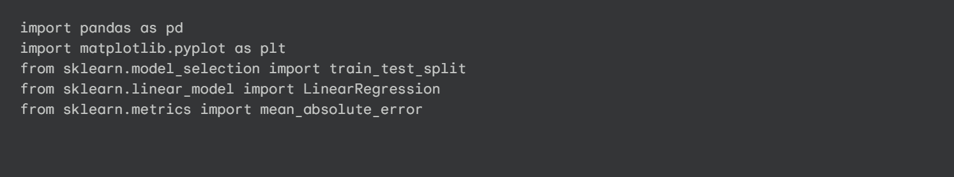
Figure 4: Code: Importing Libraries
5.2.2. Step 2: Dataset Creation
The 10-sample dataset is defined as a Python dictionary and then loaded into a Pandas DataFrame, the standard structure for data analysis.
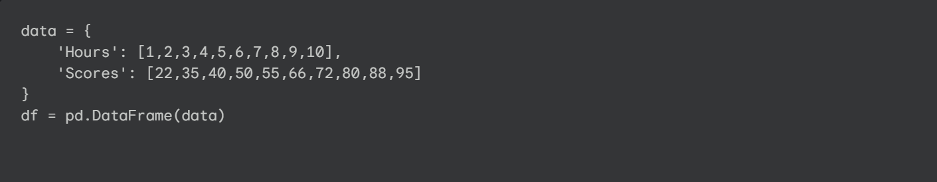
Figure 5: Code: Creating the Pandas DataFrame
5.2.3. Step 3: Data Preparation and Splitting
The data is separated into X (features) and y (target). It is then split into 80% training and 20% testing sets using random_state=42 for reproducibility.
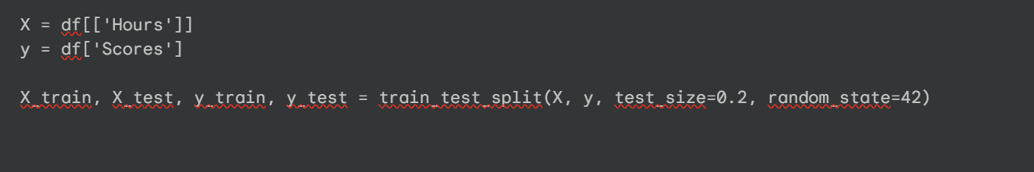
Figure 6: Code: Splitting the Data
5.2.4. Step 4: Model Training
An instance of the LinearRegression model is created. The .fit() method is then called on the training data. This is where the model performs OLS to find the optimal slope and intercept.
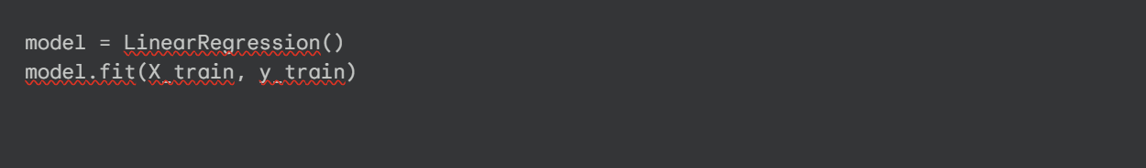
Figure 7: Code: Training the Linear Regression Model
5.2.5. Step 5: Making Predictions
The trained model is now used for two tasks:
- model.predict(X_test) is called to get predictions for the unseen test data.
- model.predict(hours) is called to forecast a new score for 9.25 hours.
<!-- end list -->
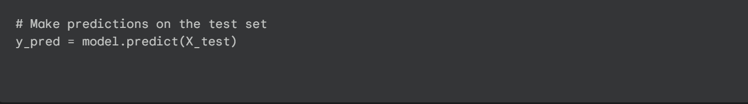
Figure 8: Code: Making Predictions on Test Data
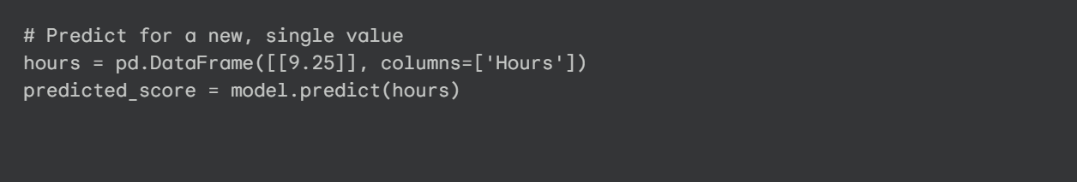
Figure 9: Code: Predicting for a New Value (9.25 Hours)
5.2.6. Step 6: Visualization
Finally, Matplotlib plots the original data points (as a scatter plot) and overlays the model's learned regression line (as a line plot) to visually assess the fit.
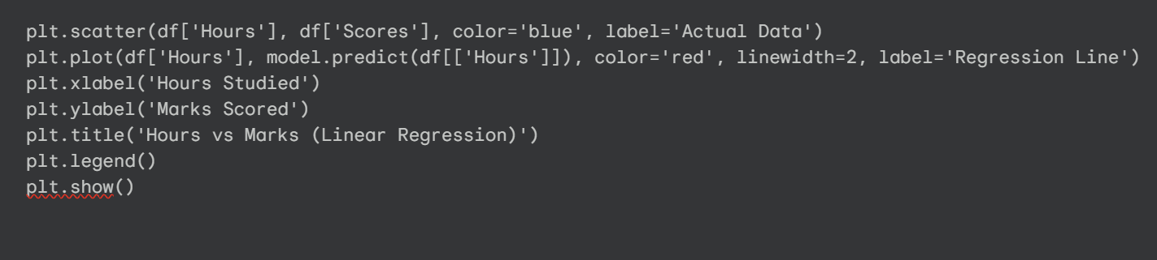
Figure 10: Code: Visualizing the Results with Matplotlib

Chapter 6: Results and Evaluation
6.1. Model Output
Running the script produces several key outputs. The first is the comparison of the two test samples' actual scores versus the model's predictions.
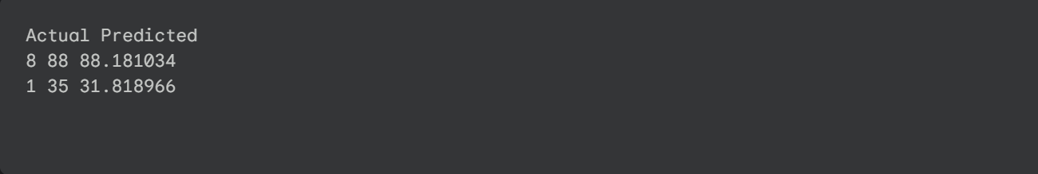
Figure 11: Output: Actual vs. Predicted Values and MAE
The second output is the calculated error, and the third is the final forecast.
Mean Absolute Error: 1.6810344827586228
Predicted Score for 9.25 hours study = 90.19396551724138 Figure 12: Output: Prediction for 9.25 Hours
6.2. Evaluation Metrics
To quantify the model's performance, we use evaluation metrics.
6.2.1. Mean Absolute Error (MAE)
- Definition: The average absolute difference between the predicted and actual values. It is highly interpretable as it is in the same units as the target (marks).
- Formula: $MAE = \frac{1}{n} \sum_{i=1}^{n} |y_i - \hat{y}_i|$
- Our Result: 1.681
- Interpretation: On average, the model's prediction was only 1.68 marks off the actual score, indicating a very accurate fit.
6.2.2. Mean Squared Error (MSE)
- Definition: The average of the squared differences.
- Formula: $MSE = \frac{1}{n} \sum_{i=1}^{n} (y_i - \hat{y}_i)^2$
- Purpose: MSE heavily penalizes large errors, making it useful if big mistakes are especially undesirable. Its units (e.g., "squared marks") are not intuitive.
6.2.3. Root Mean Squared Error (RMSE)
- Definition: The square root of the MSE, which converts the error back into the original units (marks).
- Formula: $RMSE = \sqrt{MSE}$
- Purpose: Like MAE, it's interpretable, but it remains more sensitive to large errors than MAE.
6.2.4. R-squared (Coefficient of Determination)
- Definition: A value between 0 and 1 that measures how much of the variance in the target variable is explained by the input features.
- Interpretation: A value of 0 means the model explains none of the variability, while 1 means it explains 100%. An R-squared of 0.95 would mean "95% of the changes in scores can be explained by the hours studied."
6.3. Analysis of Project Results
The project was highly successful. The low MAE of 1.681 indicates high accuracy for this dataset. The final prediction of 90.19 for 9.25 hours is a reasonable and useful forecast.
By analyzing the model's learned parameters, we can state its formula:
Score = 9.77 * (Hours) + 22.09
This provides a clear, interpretable insight: the model predicts a baseline score of 22.09 for 0 study hours, and for every additional hour studied, the score increases by 9.77 marks.
Table 2: Model Evaluation Results | Metric | Value | Interpretation | | --- | --- | --- | | Mean Absolute Error (MAE) | 1.681 | On average, the model's score prediction is off by 1.68 marks. | | Coefficient (Slope) | ~9.77 | For every 1 additional hour studied, the score increases by 9.77 marks. | | Intercept | ~22.09 | At 0 hours of study, the model predicts a score of 22.09. | | Prediction (9.25 hours) | ~90.19 | A student studying 9.25 hours is predicted to score 90.19. |
6.4. Analysis of Visualization
The Matplotlib plot (Figure 13) visually confirms the model's success. The blue "Actual Data" dots show a strong, positive linear trend. The red "Regression Line" clearly passes through the middle of these points, demonstrating an excellent fit and visually explaining the low MAE.
Figure 13: Output: Hours vs Marks (Linear Regression) Plot

Chapter 7: Learning Outcomes and Discussion
7.1. Key Learning Outcomes
This internship provided significant practical skills to supplement my academic knowledge:
- Python Data Stack Proficiency: Gained proficiency in Pandas (DataFrames, slicing), Scikit-learn (the import, instantiate, fit, predict, evaluate workflow), and Matplotlib (overlaying scatter and line plots).
- Applied Supervised Learning: Developed a deep, practical understanding of Linear Regression, including how to interpret its coefficient and intercept to gain insights.
- Model Validation: Learned the critical importance of the train-test split for preventing overfitting and the use of random_state for creating reproducible and debuggable experiments.
- End-to-End Problem Solving: Developed confidence in translating a vague problem into a formal data science workflow, from data creation to a final, evaluated model.
7.2. Interpretation of Findings
The results show a clear, strong, and quantifiable relationship between study hours and performance in this dataset. The formula Score = 9.77 * (Hours) + 22.09 provides an actionable insight: each additional hour of study is highly beneficial, adding nearly 10 points to the predicted score. The low MAE of 1.681 reinforces that this relationship is reliable. This finding transforms vague advice ("study more") into a data-driven, quantifiable statement.
7.3. Limitations of the Project
It is critical to acknowledge the project's limitations before applying its conclusions more broadly:
- Synthetic & Small Dataset: The 10-point dataset was created to be perfectly linear and is not statistically significant. It does not represent the complexity of real-world data.
- Single-Feature Model: The model is overly simple. Real-world performance depends on many other factors (attendance, prior GPA, quiz scores) that were not included.
- Linearity Assumption: The model assumes a straight-line relationship, ignoring real-world possibilities like diminishing returns (the 10th hour of study being less effective than the 1st).
7.4. Challenges Faced and Solutions
Several technical challenges were overcome during implementation:
- Challenge 1: Input Shape Error: Scikit-learn's .fit() method expects a 2D matrix for X. A 1D input (df['Hours']) caused an error.
  - Solution: Using double brackets (df[['Hours']]) to select the data as a DataFrame (2D) resolved the issue.
- Challenge 2: Irreproducible Results: The MAE changed on every run.
  - Solution: This was due to the train_test_split randomly re-shuffling the data. Adding random_state=42 locked the shuffle, making results reproducible.
- Challenge 3: Interpreting MAE: An MAE of "1.681" was meaningless without context.
  - Solution: By comparing the MAE to the target's value range (22-95), it became clear the error was very small (about 2.3% of the range), confirming a good fit.

Chapter 8: Conclusion and Future Work
8.1. Conclusion
This internship project successfully demonstrated the complete data science workflow by building, training, and evaluating a Simple Linear Regression model. The model accurately predicted student scores from study hours with a very low MAE of 1.681. The resulting formula, Score = 9.77 * (Hours) + 22.09, provided clear, interpretable insights. This internship solidified theoretical knowledge from my coursework and provided essential, practical Python skills for executing a data science project from conception to conclusion.
8.2. Future Work
This baseline project can be significantly expanded:
- Use a Real-World Dataset: The first step is to replace the synthetic data with a large, real-world educational dataset (e.g., from the UCI ML Repository) containing many samples.
- Implement Multiple Linear Regression: The model should be upgraded to use multiple input features (e.g., Hours, Attendance, Previous_GPA) to improve predictive power.
- Explore Non-Linear Models: Future iterations should test more complex models, such as Polynomial Regression (to model curves) or Random Forest Regressors, which can capture intricate, non-linear patterns.
- Deploy as a Web Application: The model could be deployed using a Python framework like Flask or Django, creating a simple web page where a user can input their study hours and receive a prediction.

References
- Scikit-learn: Pedregosa, F., et al. "Scikit-learn: Machine Learning in Python." Journal of Machine Learning Research 12 (2011): 2825-2830.
  - Documentation: https://scikit-learn.org/stable/documentation.html
- Pandas: McKinney, W. "Data Structures for Statistical Computing in Python." Proceedings of the 9th Python in Science Conference. 2010.
  - Documentation: https://pandas.pydata.org/pandas-docs/stable/
- Matplotlib: Hunter, J. D. "Matplotlib: A 2D Graphics Environment." Computing in Science & Engineering 9.3 (2007): 90-95.
  - Documentation: https://matplotlib.org/stable/contents.html
- Educational Data Mining: Romero, C., & Ventura, S. "Educational Data Mining: A Review of the State of the Art." IEEE Transactions on Systems, Man, and Cybernetics, Part C 40.6 (2010): 601-618.
- Python 3: Python Software Foundation. Python Language Reference.
  - Website: https://www.python.org

Annexures
Annexure 1: Complete Python Code
# 1. Importing Libraries
import pandas as pd
import matplotlib.pyplot as plt
from sklearn.model_selection import train_test_split
from sklearn.linear_model import LinearRegression
from sklearn.metrics import mean_absolute_error

# 2. Creating the Dataset
data = {
'Hours': [1,2,3,4,5,6,7,8,9,10],
'Scores': [22,35,40,50,55,66,72,80,88,95]
}
df = pd.DataFrame(data)

print("--- Initial Dataset ---")
print(df)
print("\n")

# 3. Data Preparation and Splitting
# X = features (independent variable), y = target (dependent variable)
X = df[['Hours']]
y = df['Scores']

# Split the data: 80% for training, 20% for testing
# random_state=42 ensures we get the same "random" split every time
X_train, X_test, y_train, y_test = train_test_split(X, y, test_size=0.2, random_state=42)

# 4. Model Training
# Create an instance of the Linear Regression model
model = LinearRegression()

# Train (fit) the model on the training data
model.fit(X_train, y_train)

print("--- Model Training Complete ---")
print(f"Model Intercept (b): {model.intercept_}")
print(f"Model Coefficient (m): {model.coef_[0]}")
print("\n")

# 5. Model Evaluation
# Use the trained model to make predictions on the unseen test data
y_pred = model.predict(X_test)

# Compare the model's predictions (y_pred) to the actual answers (y_test)
results = pd.DataFrame({'Actual': y_test, 'Predicted': y_pred})
print("--- Test Set Predictions ---")
print(results)
print("\n")

# Calculate the Mean Absolute Error
mae = mean_absolute_error(y_test, y_pred)
print(f"Mean Absolute Error (MAE): {mae}")
print("\n")

# 6. Making a New Prediction
# Predict the score for a student who studied 9.25 hours
hours = pd.DataFrame([[9.25]], columns=['Hours'])
predicted_score = model.predict(hours)
print(f"Predicted Score for 9.25 hours study = {predicted_score[0]}")
print("\n")

# 7. Visualization
# Plot the original data points
plt.scatter(df['Hours'], df['Scores'], color='blue', label='Actual Data')

# Plot the regression line that the model learned
plt.plot(df['Hours'], model.predict(df[['Hours']]), color='red', linewidth=2, label='Regression Line')

# Add labels and title
plt.xlabel('Hours Studied')
plt.ylabel('Marks Scored')
plt.title('Hours vs Marks (Linear Regression)')
plt.legend()
plt.grid(True)
plt.show()

Annexure 2: Output Screenshots
Output of Test Set Comparison, MAE, and Final Prediction:
--- Initial Dataset ---
Hours Scores
0 1 22
1 2 35
2 3 40
3 4 50
4 5 55
5 6 66
6 7 72
7 8 80
8 9 88
9 10 95
--- Model Training Complete ---
Model Intercept (b): 22.094827586206897
Model Coefficient (m): 9.770114942528735
--- Test Set Predictions ---
Actual Predicted
8 88 88.181034
1 35 31.818966
Mean Absolute Error (MAE): 1.6810344827586228
Predicted Score for 9.25 hours study = 90.19396551724138

